Filed by Freenome Holdings, Inc.
Pursuant to Rule 425
under the Securities Act of 1933, as amended
and deemed filed pursuant to Rule 14a-12
under the Securities Exchange Act of 1934, as amended
Subject Company: Perceptive Capital Solutions Corp
(Commission File No. 001- 42126)

On July 9, 2026, Riley Ennis, Co-Founder and Chief Product Officer of Freenome Holdings, Inc. (“Freenome”), a party to the proposed business combination with Perceptive Capital Solutions Corp (“PCSC”) shared the following with certain investors of Freenome:

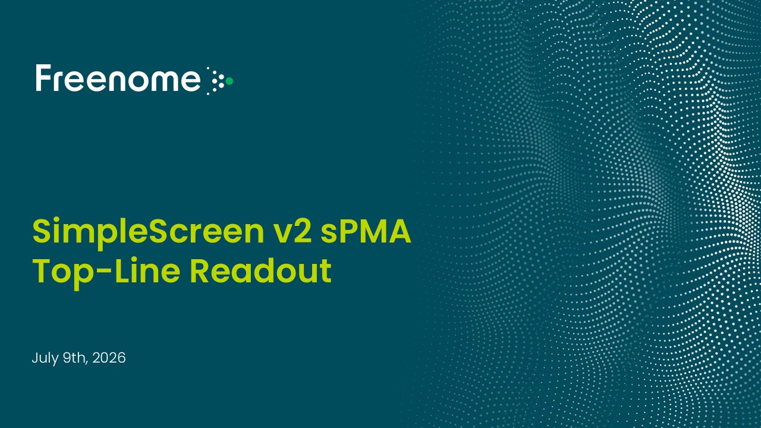
July 9th, 2026 SimpleScreen v2 sPMA Top-Line Readout

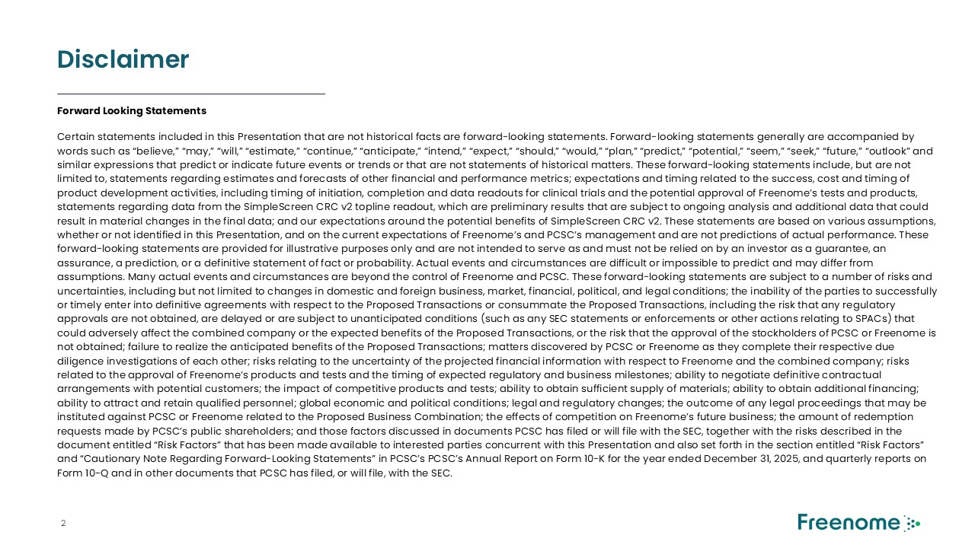
Disclaimer Forward Looking Statements Certain statements included in this Presentation that are not historical facts are forward-looking statements. Forward-looking statements generally are accompanied by words such as “believe,” “may,” “will,” “estimate,” “continue,” “anticipate,” “intend,” “expect,” “should,” “would,” “plan,” “predict,” “potential,” “seem,” “seek,” “future,” “outlook” and similar expressions that predict or indicate future events or trends or that are not statements of historical matters. These forward-looking statements include, but are not limited to, statements regarding estimates and forecasts of other financial and performance metrics; expectations and timing related to the success, cost and timing of product development activities, including timing of initiation, completion and data readouts for clinical trials and the potential approval of Freenome’s tests and products, statements regarding data from the SimpleScreen CRC v2 topline readout, which are preliminary results that are subject to ongoing analysis and additional data that could result in material changes in the final data; and our expectations around the potential benefits of SimpleScreen CRC v2. These statements are based on various assumptions, whether or not identified in this Presentation, and on the current expectations of Freenome’s and PCSC’s management and are not predictions of actual performance. These forward-looking statements are provided for illustrative purposes only and are not intended to serve as and must not be relied on by an investor as a guarantee, an assurance, a prediction, or a definitive statement of fact or probability. Actual events and circumstances are difficult or impossible to predict and may differ from assumptions. Many actual events and circumstances are beyond the control of Freenome and PCSC. These forward-looking statements are subject to a number of risks and uncertainties, including but not limited to changes in domestic and foreign business, market, financial, political, and legal conditions; the inability of the parties to successfully or timely enter into definitive agreements with respect to the Proposed Transactions or consummate the Proposed Transactions, including the risk that any regulatory approvals are not obtained, are delayed or are subject to unanticipated conditions (such as any SEC statements or enforcements or other actions relating to SPACs) that could adversely affect the combined company or the expected benefits of the Proposed Transactions, or the risk that the approval of the stockholders of PCSC or Freenome is not obtained; failure to realize the anticipated benefits of the Proposed Transactions; matters discovered by PCSC or Freenome as they complete their respective due diligence investigations of each other; risks relating to the uncertainty of the projected financial information with respect to Freenome and the combined company; risks related to the approval of Freenome’s products and tests and the timing of expected regulatory and business milestones; ability to negotiate definitive contractual arrangements with potential customers; the impact of competitive products and tests; ability to obtain sufficient supply of materials; ability to obtain additional financing; ability to attract and retain qualified personnel; global economic and political conditions; legal and regulatory changes; the outcome of any legal proceedings that may be instituted against PCSC or Freenome related to the Proposed Business Combination; the effects of competition on Freenome’s future business; the amount of redemption requests made by PCSC’s public shareholders; and those factors discussed in documents PCSC has filed or will file with the SEC, together with the risks described in the document entitled “Risk Factors” that has been made available to interested parties concurrent with this Presentation and also set forth in the section entitled “Risk Factors” and “Cautionary Note Regarding Forward-Looking Statements” in PCSC’s PCSC’s Annual Report on Form 10-K for the year ended December 31, 2025, and quarterly reports on Form 10-Q and in other documents that PCSC has filed, or will file, with the SEC.

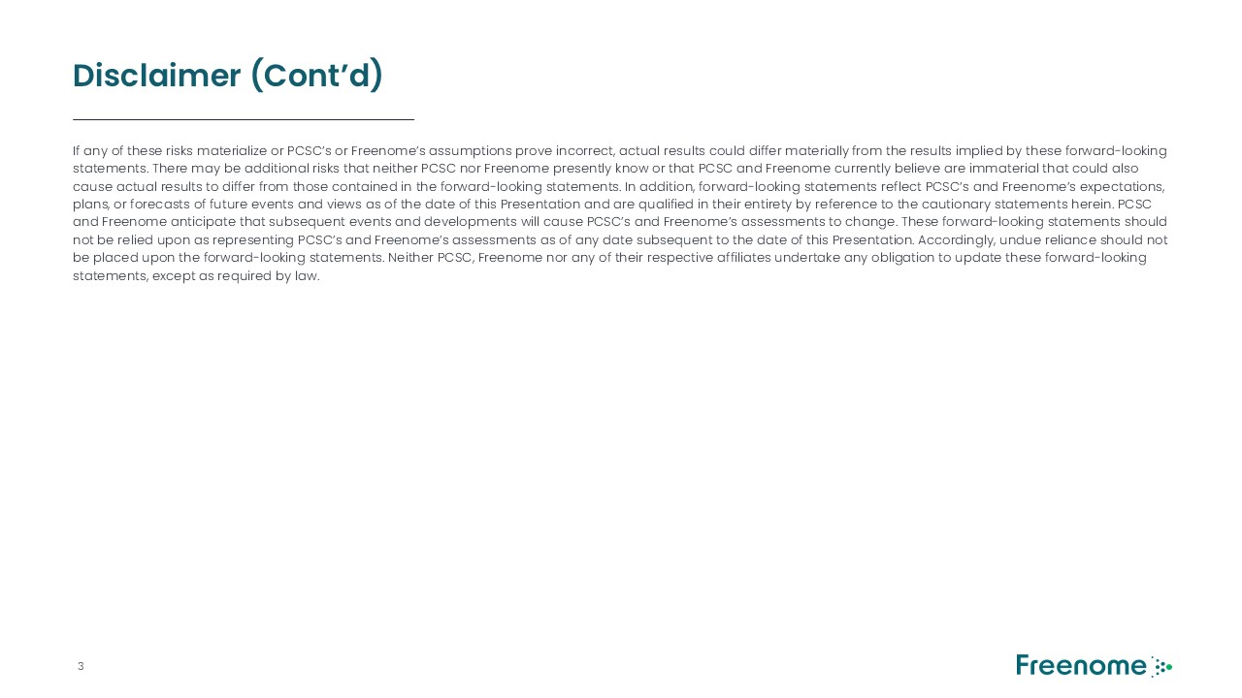
Disclaimer (Cont’d) If any of these risks materialize or PCSC’s or Freenome’s assumptions prove incorrect, actual results could differ materially from the results implied by these forward-looking statements. There may be additional risks that neither PCSC nor Freenome presently know or that PCSC and Freenome currently believe are immaterial that could also cause actual results to differ from those contained in the forward-looking statements. In addition, forward-looking statements reflect PCSC’s and Freenome’s expectations, plans, or forecasts of future events and views as of the date of this Presentation and are qualified in their entirety by reference to the cautionary statements herein. PCSC and Freenome anticipate that subsequent events and developments will cause PCSC’s and Freenome’s assessments to change. These forward-looking statements should not be relied upon as representing PCSC’s and Freenome’s assessments as of any date subsequent to the date of this Presentation. Accordingly, undue reliance should not be placed upon the forward-looking statements. Neither PCSC, Freenome nor any of their respective affiliates undertake any obligation to update these forward-looking statements, except as required by law.

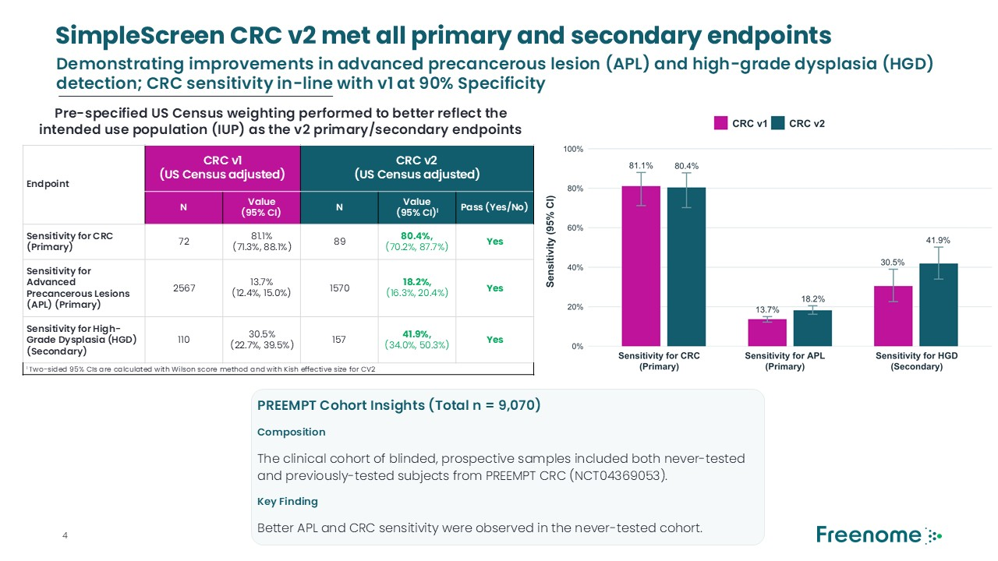
Endpoint CRC v1 (US Census adjusted) CRC v2 (US Census adjusted) N Value (95% CI) N Value (95% CI)I Pass (Yes/No) Sensitivity for CRC (Primary) 72 81.1% (71.3%, 88.1%) 89 80.4%, (70.2%, 87.7%) Yes Sensitivity for Advanced Precancerous Lesions (APL) (Primary) 2567 13.7% (12.4%, 15.0%) 1570 18.2%, (16.3%, 20.4%) Yes Sensitivity for High-Grade Dysplasia (HGD) (Secondary) 110 30.5% (22.7%, 39.5%) 157 41.9%, (34.0%, 50.3%) Yes I Two-sided 95% CIs are calculated with Wilson score method and with Kish effective size for CV2 SimpleScreen CRC v2 met all primary and secondary endpoints PREEMPT Cohort Insights (Total n = 9,070) Composition The clinical cohort of blinded, prospective samples included both never-tested and previously-tested subjects from PREEMPT CRC (NCT04369053). Key Finding Better APL and CRC sensitivity were observed in the never-tested cohort. Demonstrating improvements in advanced precancerous lesion (APL) and high-grade dysplasia (HGD) detection; CRC sensitivity in-line with v1 at 90% Specificity Pre-specified US Census weighting performed to better reflect the intended use population (IUP) as the v2 primary/secondary endpoints

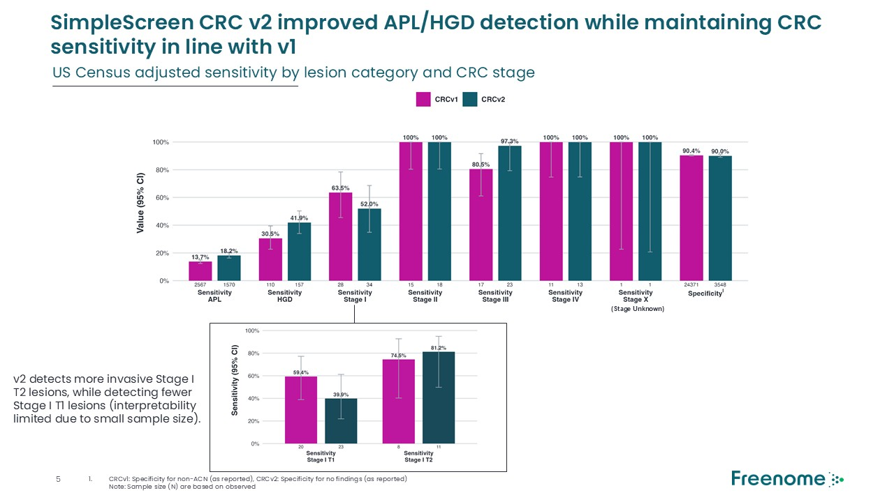
SimpleScreen CRC v2 improved APL/HGD detection while maintaining CRC sensitivity in line with v1 v2 detects more invasive Stage I T2 lesions, while detecting fewer Stage I T1 lesions (interpretability limited due to small sample size). US Census adjusted sensitivity by lesion category and CRC stage (Stage Unknown) CRCv1: Specificity for non-ACN (as reported), CRCv2: Specificity for no findings (as reported) Note: Sample size (N) are based on observed

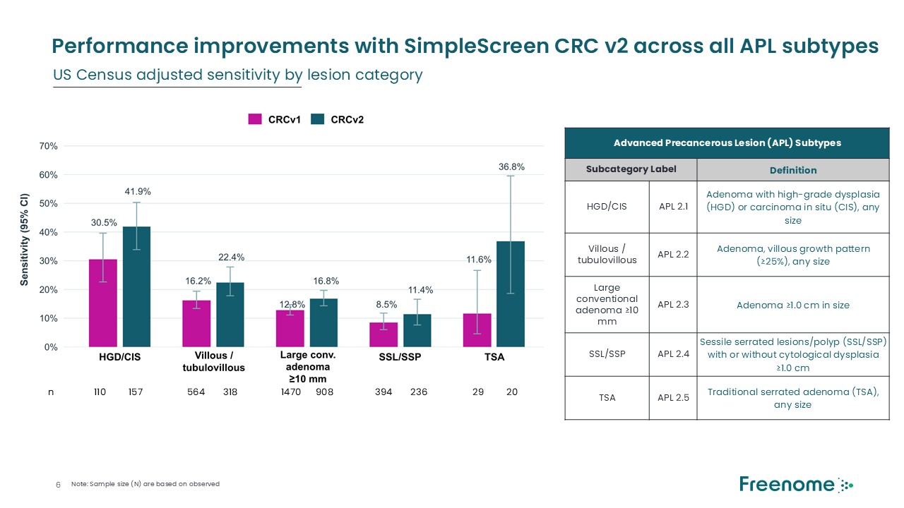
Performance improvements with SimpleScreen CRC v2 across all APL subtypes Advanced Precancerous Lesion (APL) Subtypes Subcategory Label Definition HGD/CIS APL 2.1 Adenoma with high-grade dysplasia (HGD) or carcinoma in situ (CIS), any size Villous / tubulovillous APL 2.2 Adenoma, villous growth pattern (≥25%), any size Large conventional adenoma ≥10 mm APL 2.3 Adenoma ≥1.0 cm in size SSL/SSP APL 2.4 Sessile serrated lesions/polyp (SSL/SSP) with or without cytological dysplasia ≥1.0 cm TSA APL 2.5 Traditional serrated adenoma (TSA), any size US Census adjusted sensitivity by lesion category n 157 318 908 236 20 29 110 564 1470 394 Note: Sample size (N) are based on observed

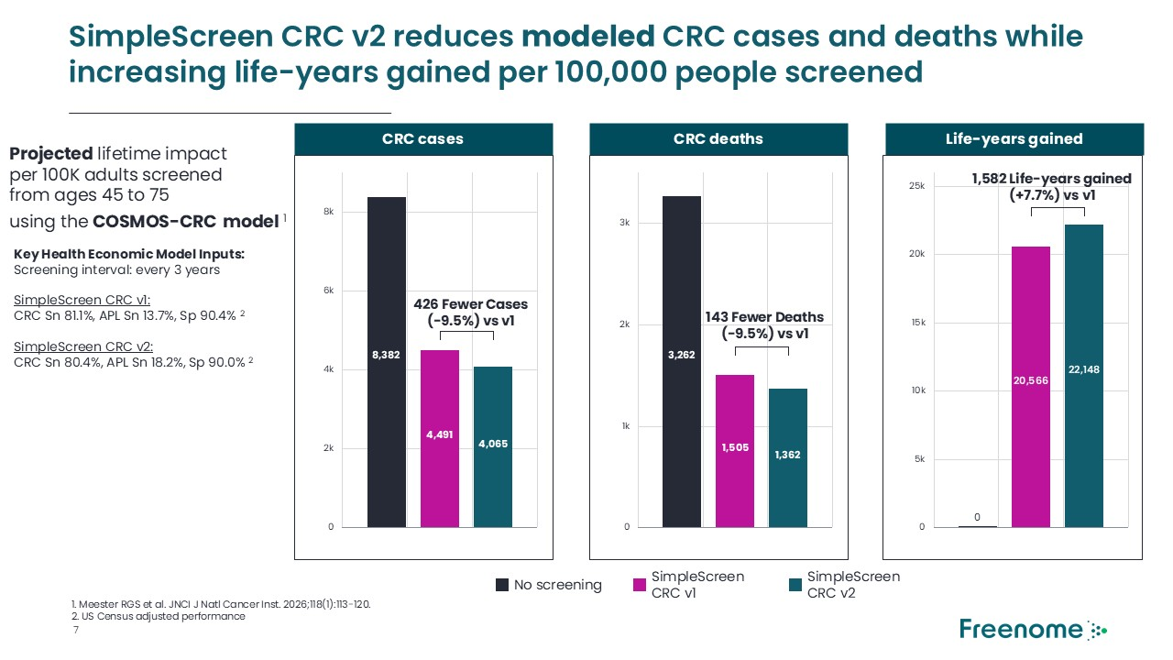
SimpleScreen CRC v2 reduces modeled CRC cases and deaths while increasing life-years gained per 100,000 people screened CRC cases CRC deaths Life-years gained Projected lifetime impact per 100K adults screened from ages 45 to 75 using the COSMOS-CRC model 1 Key Health Economic Model Inputs: Screening interval: every 3 years SimpleScreen CRC v1: CRC Sn 81.1%, APL Sn 13.7%, Sp 90.4% 2 SimpleScreen CRC v2: CRC Sn 80.4%, APL Sn 18.2%, Sp 90.0% 2 1. Meester RGS et al. JNCI J Natl Cancer Inst. 2026;118(1):113-120. 2. US Census adjusted performance 0 2k 4k 6k 8k 8,382 4,491 426 Fewer Cases (-9.5%) vs v1 0 1k 2k 3k 3,262 1,505 143 Fewer Deaths (-9.5%) vs v1 0 5k 10k 15k 20k 25k 20,566 22,148 1,582 Life-years gained (+7.7%) vs v1 SimpleScreen CRC v1 SimpleScreen CRC v2 4,065 1,362 0 No screening

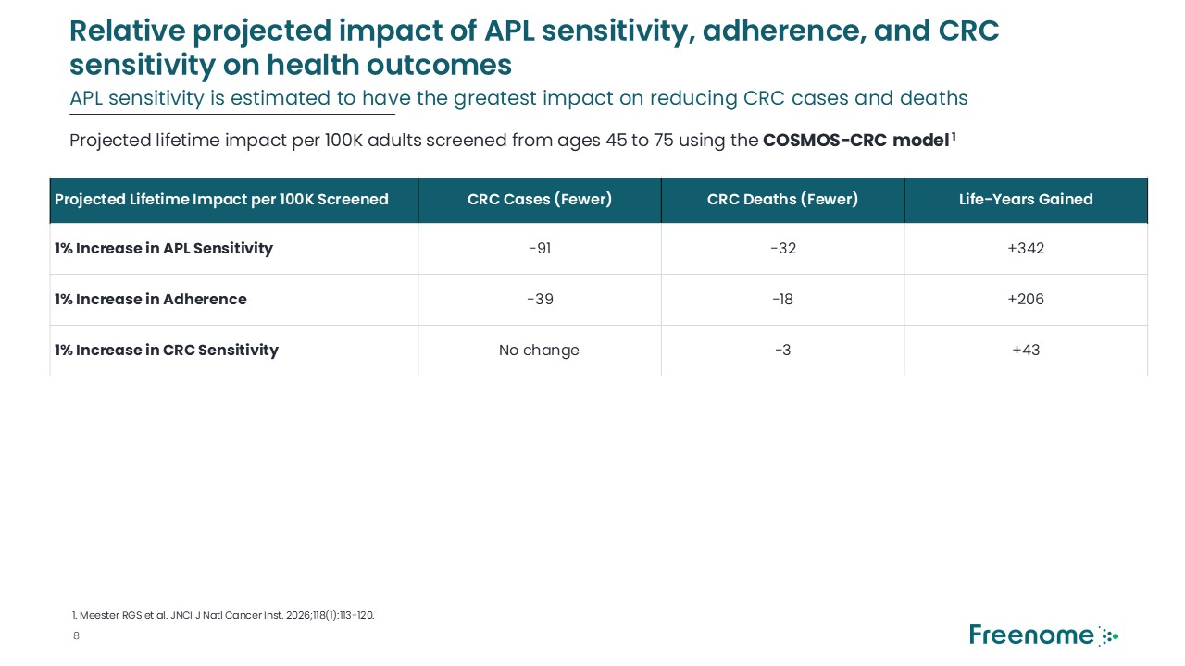
Relative projected impact of APL sensitivity, adherence, and CRC sensitivity on health outcomes Projected Lifetime Impact per 100K Screened CRC Cases (Fewer) CRC Deaths (Fewer) Life-Years Gained 1% Increase in APL Sensitivity -91 -32 +342 1% Increase in Adherence -39 -18 +206 1% Increase in CRC Sensitivity No change -3 +43 1. Meester RGS et al. JNCI J Natl Cancer Inst. 2026;118(1):113-120. Projected lifetime impact per 100K adults screened from ages 45 to 75 using the COSMOS-CRC model 1 APL sensitivity is estimated to have the greatest impact on reducing CRC cases and deaths


Company Roadmap

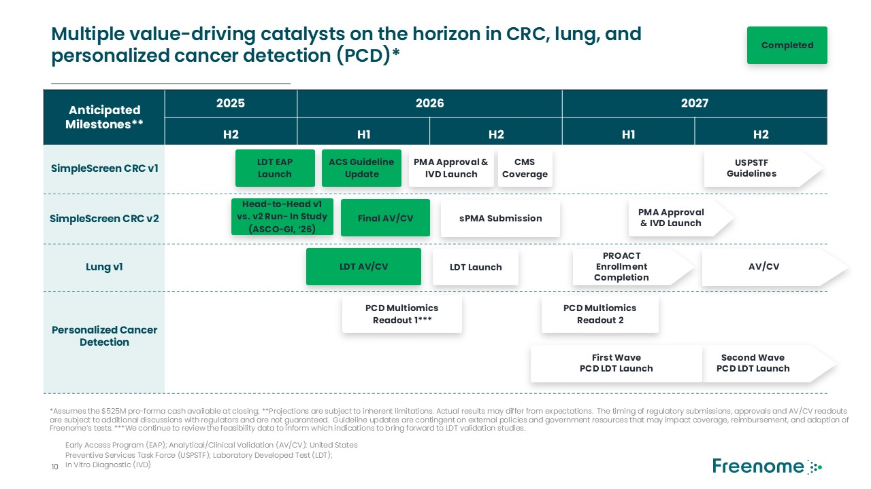
Multiple value-driving catalysts on the horizon in CRC, lung, and personalized cancer detection (PCD)* Early Access Program (EAP); Analytical/Clinical Validation (AV/CV): United States Preventive Services Task Force (USPSTF); Laboratory Developed Test (LDT); In Vitro Diagnostic (IVD) Anticipated Milestones** 2025 2026 2027 H2 H1 H2 H1 H2 SimpleScreen CRC v1 SimpleScreen CRC v2 Lung v1 Personalized Cancer Detection LDT EAP Launch PMA Approval & IVD Launch CMS Coverage USPSTF Guidelines sPMA Submission PMA Approval & IVD Launch LDT Launch PROACT Enrollment Completion PCD Multiomics Readout 1*** Second WavePCD LDT Launch ACS Guideline Update Head-to-Head v1 vs. v2 Run- In Study (ASCO-GI, ‘26) Final AV/CV AV/CV First WavePCD LDT Launch LDT AV/CV *Assumes the $525M pro-forma cash available at closing; **Projections are subject to inherent limitations. Actual results may differ from expectations. The timing of regulatory submissions, approvals and AV/CV readouts are subject to additional discussions with regulators and are not guaranteed. Guideline updates are contingent on external policies and government resources that may impact coverage, reimbursement, and adoption of Freenome’s tests. ***We continue to review the feasibility data to inform which indications to bring forward to LDT validation studies. PCD Multiomics Readout 2 Completed


Appendix

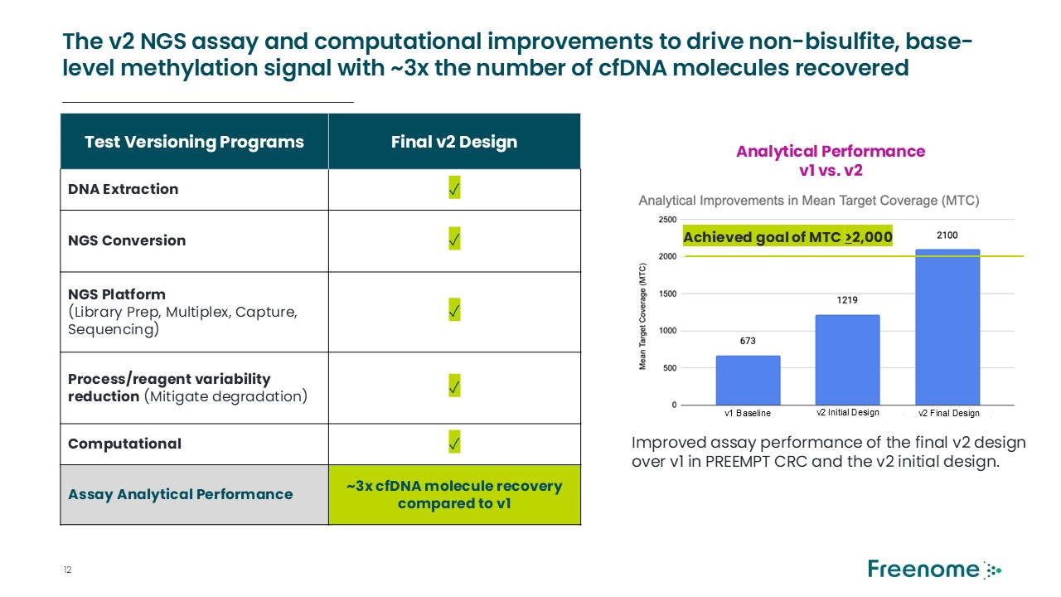
Test Versioning Programs Final v2 Design DNA Extraction ✓ NGS Conversion ✓ NGS Platform (Library Prep, Multiplex, Capture, Sequencing) ✓ Process/reagent variability reduction (Mitigate degradation) ✓ Computational ✓ Assay Analytical Performance ~3x cfDNA molecule recovery compared to v1 Analytical Performance v1 vs. v2 Improved assay performance of the final v2 design over v1 in PREEMPT CRC and the v2 initial design. Achieved goal of MTC >2,000 The v2 NGS assay and computational improvements to drive non-bisulfite, base-level methylation signal with ~3x the number of cfDNA molecules recovered v1 Baseline - v2 Initial Design - - v2 Final Design -

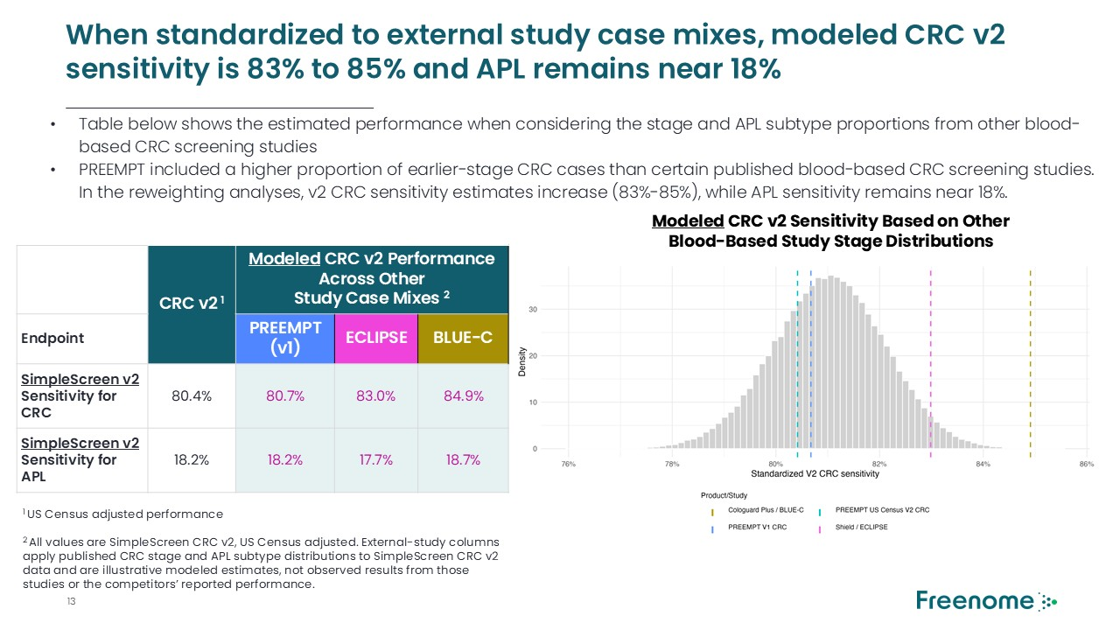
When standardized to external study case mixes, modeled CRC v2 sensitivity is 83% to 85% and APL remains near 18% Table below shows the estimated performance when considering the stage and APL subtype proportions from other blood-based CRC screening studies PREEMPT included a higher proportion of earlier-stage CRC cases than certain published blood-based CRC screening studies. In the reweighting analyses, v2 CRC sensitivity estimates increase (83%-85%), while APL sensitivity remains near 18%. CRC v2 1 Modeled CRC v2 Performance Across Other Study Case Mixes 2 Endpoint PREEMPT (v1) ECLIPSE BLUE-C SimpleScreen v2 Sensitivity for CRC 80.4% 80.7% 83.0% 84.9% SimpleScreen v2 Sensitivity for APL 18.2% 18.2% 17.7% 18.7% Modeled CRC v2 Sensitivity Based on Other Blood-Based Study Stage Distributions 1 US Census adjusted performance 2 All values are SimpleScreen CRC v2, US Census adjusted. External-study columns apply published CRC stage and APL subtype distributions to SimpleScreen CRC v2 data and are illustrative modeled estimates, not observed results from those studies or the competitors’ reported performance.

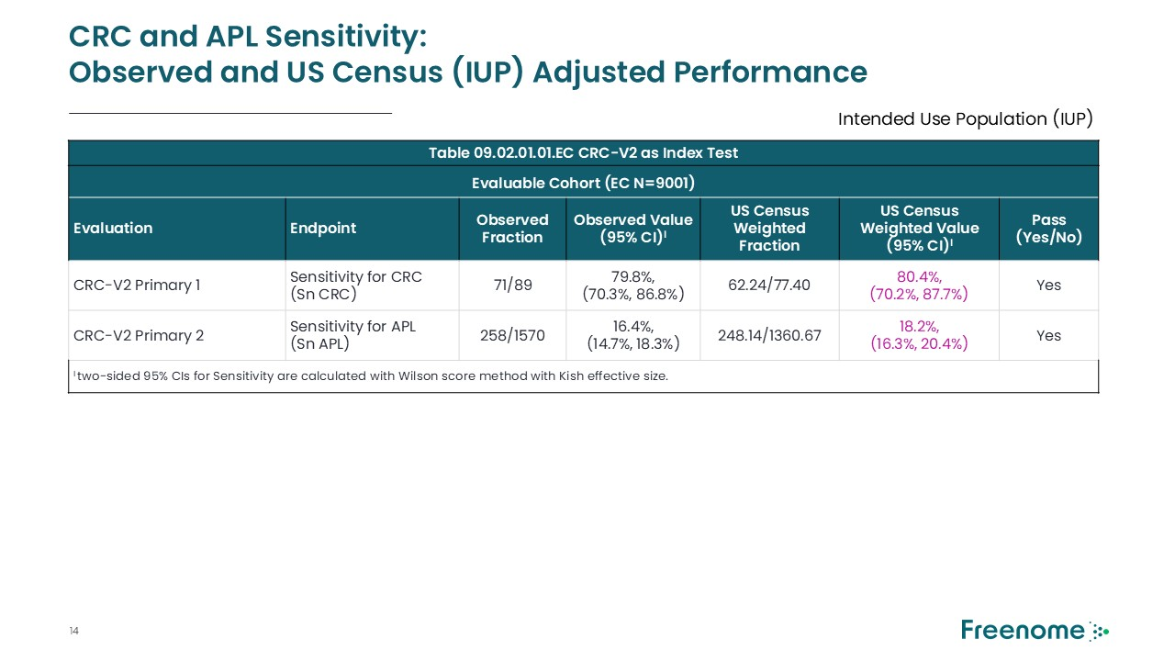
CRC and APL Sensitivity: Observed and US Census (IUP) Adjusted Performance Table 09.02.01.01.EC CRC-V2 as Index Test Evaluable Cohort (EC N=9001) Evaluation Endpoint Observed Fraction Observed Value (95% CI)I US Census Weighted Fraction US Census Weighted Value (95% CI)I Pass (Yes/No) CRC-V2 Primary 1 Sensitivity for CRC(Sn CRC) 71/89 79.8%, (70.3%, 86.8%) 62.24/77.40 80.4%, (70.2%, 87.7%) Yes CRC-V2 Primary 2 Sensitivity for APL(Sn APL) 258/1570 16.4%, (14.7%, 18.3%) 248.14/1360.67 18.2%, (16.3%, 20.4%) Yes I two-sided 95% CIs for Sensitivity are calculated with Wilson score method with Kish effective size. Intended Use Population (IUP)

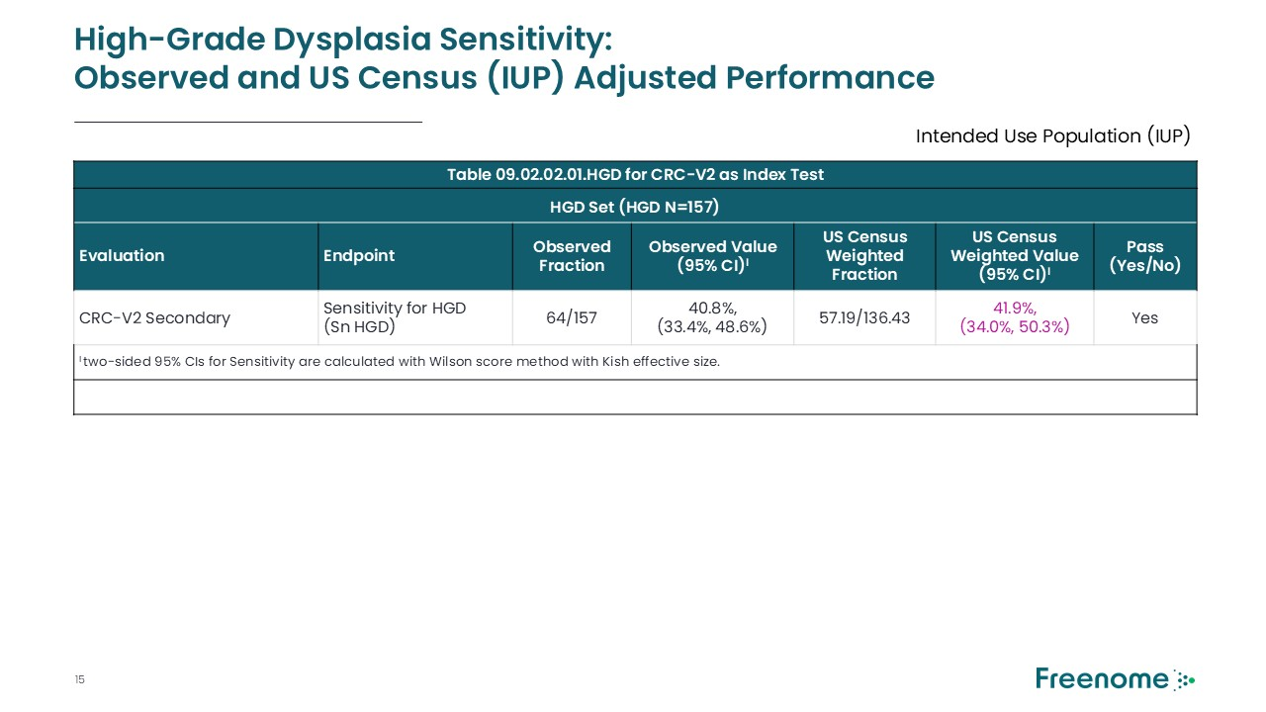
High-Grade Dysplasia Sensitivity: Observed and US Census (IUP) Adjusted Performance Table 09.02.02.01.HGD for CRC-V2 as Index Test HGD Set (HGD N=157) Evaluation Endpoint Observed Fraction Observed Value (95% CI)I US Census Weighted Fraction US Census Weighted Value (95% CI)I Pass (Yes/No) CRC-V2 Secondary Sensitivity for HGD(Sn HGD) 64/157 40.8%, (33.4%, 48.6%) 57.19/136.43 41.9%, (34.0%, 50.3%) Yes I two-sided 95% CIs for Sensitivity are calculated with Wilson score method with Kish effective size. Intended Use Population (IUP)

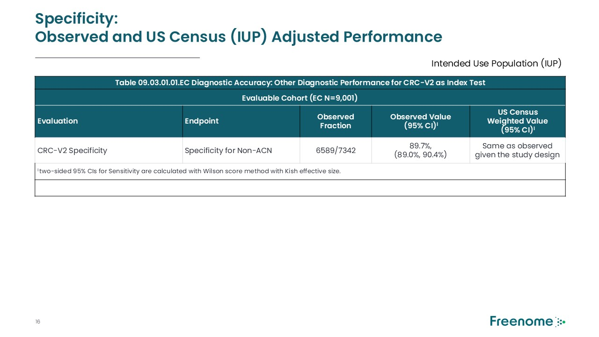
Specificity: Observed and US Census (IUP) Adjusted Performance Table 09.03.01.01.EC Diagnostic Accuracy: Other Diagnostic Performance for CRC-V2 as Index Test Evaluable Cohort (EC N=9,001) Evaluation Endpoint Observed Fraction Observed Value (95% CI)I US Census Weighted Value (95% CI)I CRC-V2 Specificity Specificity for Non-ACN 6589/7342 89.7%, (89.0%, 90.4%) Same as observed given the study design I two-sided 95% CIs for Sensitivity are calculated with Wilson score method with Kish effective size. Intended Use Population (IUP)



Additional Information about the Proposed Business Combination and Where to Find It

As previously disclosed, Perceptive Capital Solutions Corp. (“PCSC”), Freenome Holdings, Inc. (“Freenome”), StarNet Merger Sub I, Corp., a Delaware corporation and a wholly-owned subsidiary of PCSC, and StarNet Merger Sub II, LLC, a Delaware limited liability company and a wholly-owned subsidiary of PCSC, entered into a definitive business combination agreement, dated as of December 5, 2025 (as it may be further amended, restated, supplemented or otherwise modified from time to time, the “Business Combination Agreement”), pursuant to which, subject to the satisfaction or waiver of the conditions therein, the parties thereto will consummate the Business Combination. Upon closing of the transaction, PCSC will be renamed “Freenome, Inc.” (“New Freenome”). The Business Combination will be submitted to shareholders of PCSC for their consideration. PCSC and Freenome jointly filed a registration statement on Form S-4 (the “Registration Statement”) with the U.S. Securities and Exchange Commission (the “SEC”), which was declared effective by the SEC on June 17, 2026, and includes a proxy statement/prospectus that is both the proxy statement of PCSC and a prospectus of New Freenome relating to the shares to be issued in connection with the Business Combination (the “Proxy Statement/Prospectus”). The definitive Proxy Statement/Prospectus was mailed to PCSC’s shareholders of record as of June 12, 2026, the record date established for voting on the Business Combination. PCSC, Freenome and/or New Freenome may also file other relevant documents regarding the Business Combination with the SEC.

Before making any voting or investment decision, PCSC shareholders, Freenome stockholders, and other interested persons are urged to read the definitive Proxy Statement/Prospectus and other documents previously filed with the SEC in connection with the Business Combination, because these documents contain important information about PCSC, Freenome, New Freenome and the Business Combination. Shareholders can obtain free copies of the Registration Statement, the definitive Proxy Statement/Prospectus and other documents filed by PCSC with the SEC, without charge, at the SEC’s website located at www.sec.gov, or by directing a written request to Perceptive Capital Solutions Corp, 51 Astor Place, 10th Floor, New York, New York 10003.

Forward-Looking Statements

This communication includes forward-looking statements. Forward-looking statements generally are accompanied by words such as “believe,” “may,” “will,” “estimate,” “continue,” “anticipate,” “intend,” “expect,” “should,” “would,” “plan,” “predict,” “potential,” “seem,” “seek,” “future,” “outlook” and similar expressions that predict or indicate future events or trends or that are not statements of historical matters. These forward-looking statements include, but are not limited to, statements regarding estimates and forecasts of other financial and performance metrics and projections of market opportunity; expectations and timing related to the success, cost and timing of product development activities, including timing of initiation, completion and data readouts for clinical trials and the potential approval of Freenome’s tests and products, the size and growth potential of the markets for Freenome’s tests and products; financing and other business milestones; potential benefits of the proposed Business Combination and other related transactions; and expectations relating to the proposed Business Combination and other related transactions. These statements are based on various assumptions, whether or not identified in this communication, and on the current expectations of Freenome’s and PCSC’s management and are not predictions of actual performance. These forward-looking statements are provided for illustrative purposes only and are not intended to serve as and must not be relied on by an investor as a guarantee, an assurance, a prediction, or a definitive statement of fact or probability. Actual events and circumstances are difficult or impossible to predict and may differ from assumptions. Many actual events and circumstances are beyond the control of Freenome and PCSC. These forward-looking statements are subject to a number of risks and uncertainties, including but not limited to changes in domestic and foreign business, market, financial, political, and legal conditions; the inability of the parties to successfully or timely consummate the proposed Business Combination and other related transactions; risks related to the approval of Freenome’s products and tests and the timing of expected regulatory and business milestones; ability to negotiate definitive contractual arrangements with potential customers; the impact of competitive products and tests; ability to obtain sufficient supply of materials; ability to obtain additional financing; ability to attract and retain qualified personnel; global economic and political conditions; and the occurrence of any event, change or other circumstance that could give rise to the termination of the Business Combination Agreement. Additional risks related to Freenome’s business include, but are not limited to: uncertainty regarding outcomes of Freenome’s product development activities, including timing of initiation, completion and data readouts for clinical trials and the potential approval of Freenome’s tests and products; risks associated with Freenome’s efforts to commercialize its product candidates; Freenome’s ability to maintain its existing agreements with third parties and to negotiate and enter into new definitive agreements on favorable terms, if at all; the impact of competing product candidates on Freenome’s business; intellectual property-related claims; Freenome’s ability to attract and retain qualified personnel; and Freenome’s ability to source the raw materials for its product candidates. Additional risks related to PCSC and Freenome include those factors discussed in the Registration Statement and definitive Proxy Statement/Prospectus and also set forth in the section entitled “Risk Factors” and “Cautionary Note Regarding Forward-Looking Statements” in PCSC’s Quarterly Report on Form 10-Q for the quarter ended March 31, 2026, PCSC’s Annual Report on Form 10-K for the year ended December 31, 2025, and in those documents that PCSC has filed, or will file, with the SEC.

If any of these risks materialize or PCSC’s or Freenome’s assumptions prove incorrect, actual results could differ materially from the results implied by these forward-looking statements. There may be additional risks that neither PCSC nor Freenome presently know or that PCSC and Freenome currently believe are immaterial that could also cause actual results to differ from those contained in the forward-looking statements. In addition, forward-looking statements reflect PCSC’s and Freenome’s expectations, plans, or forecasts of future events and views as of the date of this communication and are qualified in their entirety by reference to the cautionary statements herein. PCSC and Freenome anticipate that subsequent events and developments will cause PCSC’s and Freenome’s assessments to change. These forward-looking statements should not be relied upon as representing PCSC’s and Freenome’s assessments as of any date subsequent to the date of this communication. Accordingly, undue reliance should not be placed upon the forward-looking statements. Neither PCSC, Freenome nor any of their respective affiliates undertake any obligation to update these forward-looking statements, except as required by law.

Participants in the Solicitation

PCSC, Freenome, and their respective directors and executive officers may be deemed to be participants in the solicitations of proxies from PCSC’s shareholders with respect to the Business Combination and the other matters set forth in the Registration Statement. Information regarding PCSC’s directors and executive officers, and a description of their interests in PCSC is contained in the definitive Proxy Statement/Prospectus, which was filed with the SEC and may be obtained free of charge at the SEC’s website located at www.sec.gov, or by directing a request to Perceptive Capital Solutions Corp, 51 Astor Place, 10th Floor, New York, New York 10003. Additional information regarding the interests of such participants in the proxy solicitation and a description of their direct and indirect interests, is contained in the definitive Proxy Statement/Prospectus. Shareholders, potential investors and other interested persons should read the definitive Proxy Statement/Prospectus carefully before making any voting or investment decisions. You may obtain free copies of these documents from the sources described above.

No Offer or Solicitation

This communication shall not constitute an offer to sell, or the solicitation of an offer to buy, or a recommendation to purchase, any securities, in any jurisdiction, or the solicitation of any vote, consent or approval in any jurisdiction in connection with the proposed business combination or any related transactions, nor shall there be any sale of securities in any states or jurisdictions in which such offer, solicitation or sale would be unlawful. This communication is not, and under no circumstances is to be construed as, a prospectus, an advertisement or a public offering of the securities described herein in the United States or any other jurisdiction. No offer of securities shall be made except by means of a prospectus meeting the requirements of Section 10 of the Securities Act of 1933, as amended, or exemptions therefrom. INVESTMENT IN ANY SECURITIES DESCRIBED HEREIN HAS NOT BEEN APPROVED BY THE SEC OR ANY OTHER REGULATORY AUTHORITY NOR HAS ANY AUTHORITY PASSED UPON OR ENDORSED THE MERITS OF THE OFFERING OR THE ACCURACY OR ADEQUACY OF THE INFORMATION CONTAINED HEREIN. ANY REPRESENTATION TO THE CONTRARY IS A CRIMINAL OFFENSE.

